2.6-2 (b,c))

$$H\left(s\right)= \frac{s^{3}}{s^{3}+2s^{2}+2s+1}$$

First, we need a $w_{0}$ value. Let’s plot the prototype high-pass transfer function.

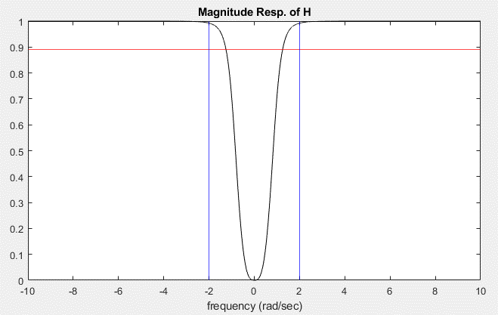

It looks like $w_{0}$ is around 2 rad/sec. Let’s use a cost function in MATLAB to figure out the exact frequency

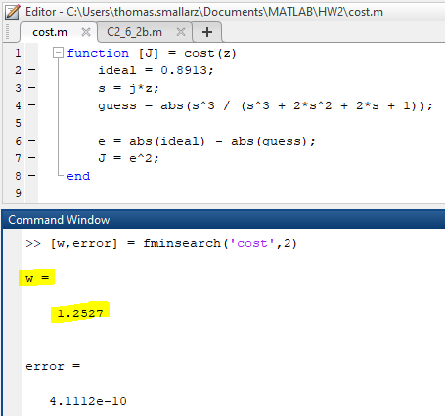

b) Low-pass to High-pass transformation

$s→\frac{ω_{0}ω_{1}}{s} ω→\frac{ω_{0}ω_{1}}{-ω}$ $where ω_{0}ω_{1}=1.2527*5=6.2637$

In MATLAB,

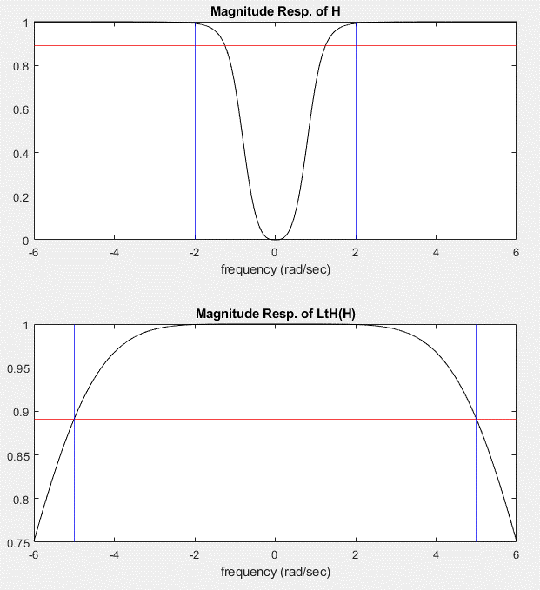

c) Lowpass-to-bandpass transformation with $ω_{1}=3\frac{rad}{sec} and ω_{2}=4\frac{rad}{sec}$

$$s→ω_{0}\frac{s^{2}+ω_{1}ω_{2}}{s(ω_{2}-ω_{1})}$$

In MATLAB,

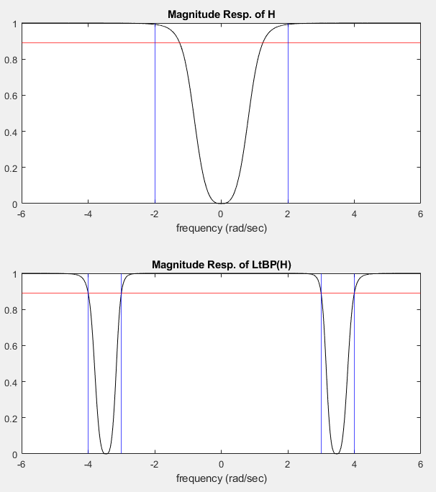

MATLAB FOR 2.6-2 (b,c)

